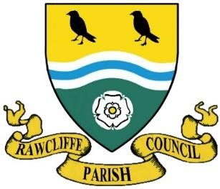
RAWCLIFFE PARISH COUNCIL

Clerk: Mrs V. Baggott
65 Bloomhill Court,
Moorends,
Doncaster
DN8 4PF 6/26
clerk@rawcliffeparishcouncil.org.uk

16th June 2026

You are hereby summonsed to attend the meeting of Rawcliffe Parish Council to be held at St James’ Church, The Green, Rawcliffe at 7pm on Wednesday 24th June 2026

Agenda
To propose and second the minutes of Rawcliffe Parish Council meeting held
Wednesday 27th May 2026

Apologies for Absence
Cllr D Chimodis, Cllr P Sykes, Cllr J Taylor

23. To record declarations of interest on items listed on the agenda and the nature of such interest
24.To note dispensation given to councillors on items on the agenda
25. To receive the Parish Clerks Report
26.To receive the East Riding Councillors Report
27. Risk Assessment need proposer and seconder
28. Items from council members
- Website – Cllr. Elle Gleeson
- Speed report-Cllr.Elle Gleeson/Cllr. S Harris
- Village Pump- Cllr J Taylor
- Planters
- Cemetry – Memorial Tree-Cllr J Emberton-Leverson
- Cleaning War Memorial -
- Bench for bus stop Rawcliffe
- Festival Village Green- ~Cllr E Gleeson
- N Power
- Water from Cemetery
- Procedure
- Office/e-mail
- Flag
- Drainage Board
29. Update from Street Maintenance Operative
30.Update from Rawcliffe Village Hall Committee 7/26

31.Public Participation
Close the meeting for Public Participation
Public Participation – Any member of the public named on the electoral role is allowed no more than 5 minutes to address members of the council.
The Chairman will re-open the meeting
32.To consider, approve and sign the Councils bank reconciliation and receipts and payments Summary and to be signed by the Chair and Responsible Financial Officer.

33. Next Meeting 22nd July 2026

Yours sincerely
Clerk to the Council

