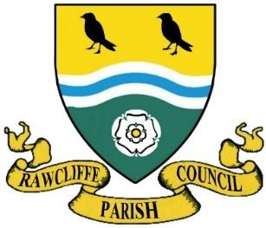
RAWCLIFFE PARISH COUNCIL

Clerk: Mrs V. Baggott
65 Bloomhill Court,
Moorends,
Doncaster
DN8 4PF
clerk@rawcliffeparishcouncil.org.uk

17th March 2026
Local Government Act 1972

PARISH COUNCIL

HEREBY GIVES NOTICE THAT

The Annual Meeting of Rawcliffe Parish will be held
On Wednesday 25th March 2026 at 6.00pm
In
St James Church, The green, Rawcliffe

Such persons only as registered as Local Government Electors for the parish
Will be entitled to speak at the meeting, but the meeting will be open to the public during the proceedings unless the parish Meeting by resolution otherwise direct.

The business to be transacted at the meeting will be as follows

AGENDA
To note and approve the minutes of the last meeting
To receive the Chair’s report
To Consider any correspondence received
To Discuss any matters arising from person’s present

Close of Meeting

Councillor: J Emberson-Leverton

Chair person of Rawcliffe Parish Council

Dated this 20th March 2026

