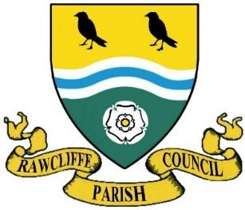
RAWCLIFFE PARISH COUNCIL

Clerk: Mrs V. Baggott
65 Bloomhill Court
Moorends
Doncaster
DN8 4PF
Phone number 07761 801122
clerk@rawcliffeparishcouncil.org.uk

17 October 2025

You are hereby summoned to attend the meeting of Rawcliffe Parish Council to be held at St James’ Church, The Green, Rawcliffe at 7pm on Wednesday 22nd October 2025

Agenda

1. Apologies for Absence

2. To propose and second the minutes of Rawcliffe Parish Council meeting held Wednesday 24th September 2025

3 To record declarations of interest on items listed on the agenda and the nature of such interest
Non pecuniary Councillor R Chapman – Pump
Non Pecuniary Councillor J Emberton-Leverson – Cemetery.

4. To note dispensation given to councillors on items on the agenda

5. To receive the Parish Clerks Report

To receive the East Riding Councillors Report

6. Public Participation Public Participation – Any member of the public named on the electoral role is allowed no more than 5 minutes to address members of the council

The Chairman will re-open the meeting

7. Items from council members
- P A System
- Litter Bins
- Cemetery Baskets
- Mandate
- Grass Cutting
- Plant Pots
- Remembance Day
- Community Grants
- Yorkshire Flag
- Speeding
- Pump

8. Update from Street Maintenance Operative

9. Update from Rawcliffe Village Hall Committee

10 Section 137 LGA 1972 – Grant Applications

11 Burials and Memorial Notifications.
0 burials 1 Memorial notification

12. Date of the Next Meeting 26th November 2025

Yours sincerely
Clerk to the Council

