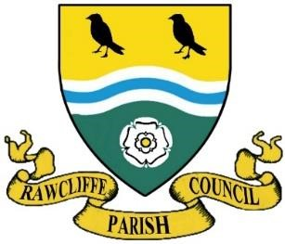**RAWCLIFFE PARISH COUNCIL**

**Clerk: Mrs V. Baggott**

**65 Bloomhill Court,**

**Moorends,**

**Doncaster**

**DN8 4PF**

**Phone number 07761 801122**

**clerk@rawcliffeparishcouncil.org.uk**

19th June 2025

You are hereby summoned to attend the meeting of Rawcliffe Parish Council to be held at St James’ Church, The Green, Rawcliffe at 7pm on Wednesday 25 June 2025

Agenda

1. Apologies for Absence
2. To propose and second the minutes of Rawcliffe Parish Council meeting held Wednesday 28th May 2025
3. To record declarations of interest on items listed on the agenda and the nature of such interest
4. To note dispensation given to councillors on items on the agenda
5. To receive the Parish Clerk and Chairman's Report
6. To receive the East Riding Councillors Report
7. To further discuss the Risk Assessment
8. Items from council members
9. Reminder for the special meeting called regarding speeding issues. This will take place on Saturday 28th June in Rawcliffe Village Hall. All residents are invited.
10. Update from Street Maintenance Operative
11. Update from Rawcliffe Village Hall Committee
12. Section 137 LGA 1972 – Grant Applications
13. Rawcliffe Cemetery Burial and Memorial Notification
14. Public Participation

**Chairman will close the meeting for Public Participation   
  
Public Participation** – Any member of the public named on the electoral role is allowed no more than 5 minutes to address members of the council.

**The Chairman will re-open the meeting**

14 Accounts

1. Payments, Receipts,
2. Banking Authority
3. AGAR a report on the progress of 2024/25 Audit
4. Mandate

Date of the Next Meeting 23rd July 2025

Yours sincerely

Clerk to the Council