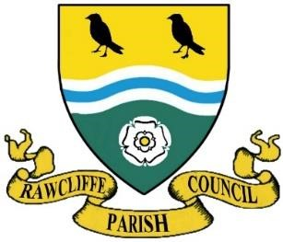**RAWCLIFFE PARISH COUNCIL**

**Clerk: Mrs. Vicky Whiteley**

**Old Fold Yard House, West End, Rawcliffe, DN14 8RW**

**Tel: 07761 801122 e-mail: clerk@rawcliffeparishcouncil.org.uk**

15 January 2025

You are hereby summonsed to attend the meeting of Rawcliffe Parish Council to be held at St James’ Church, The Green, Rawcliffe at 7pm on Wednesday 22 January 2025

Agenda

1. Election of Chairman
2. Co-option of Councillor
3. To propose and second the minutes of Rawcliffe Parish Council meeting held Wednesday 27 November 2024
4. Apologies for Absence
5. To record declarations of interest on items listed on the agenda and the nature of such interest
6. To note dispensation given to councillors on items on the agenda
7. To receive the Parish Clerks Report
8. To receive the East Riding Councillors Report
9. Items from council members
10. Date of Summer Festival – Cllr. Elle Gleeson
11. Speed Report – Cllr. Elle Gleeson
12. Update from Street Maintenance Operative
13. Update of Parish Council Insurance to cover Rawcliffe Village Hall
14. Section 137 LGA 1972 – Grant Applications
15. Rawcliffe Play and Sk8 Park and Rawcliffe Bridge Play Park Inspection
16. Rawcliffe Cemetery Burial and Memorial Notification
17. Clerk and HR Associated Correspondence
18. Public Participation

**Close the meeting for Public Participation**

Public Participation – Any member of the public named on the electoral role is allowed no more than 5 minutes to address members of the council.

**The Chairman will re-open the meeting**

1. Accounts

Payments, Receipts, Budget including councillors’ future projects, Precept 2025/2026, Updated Financial Recommendations, Public Interest Report Recommendations, Approval of updated budget and recommendations.

1. Date of the Next Meeting

Yours sincerely

Clerk to the Council