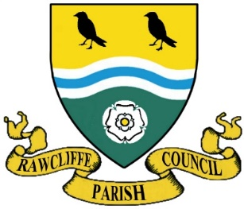
RAWCLIFFE PARISH COUNCIL

Clerk: Mrs. Vicky Whiteley
Old Fold Yard House, West End, Rawcliffe, DN14 8RW
Tel: 07761 801122 e-mail: clerk@rawcliffeparishcouncil.org.uk
20 January 2021

Meeting of Rawcliffe Parish Council to be held on Wednesday 27 January 2021 by remote dial up
Members of the public are welcome to attend the meeting in a public forum at 7pm. Whilst Rawcliffe Parish Council still support the rights of people to do this, during the current crisis relating to COVID19 for Health and Safety reasons, and to ensure physical social-isolation guidelines car be followed, meetings will be held digitally via Zoom online technology. Members of the Public are welcome to join the meeting.
Meeting ID 932.537.370.75 Password 709080

Agenda
- Apologies for Absence
- To propose and second minutes of the meeting held on Wednesday 25 November 2020.
- To note declarations of interest by members in items on this agenda and the nature of such
interest.
- To note dispensation given to members of the council on agenda items listed below.
The Chairman will close the meeting for the following agenda point
Public Participation – Any member of the public named on the Register of Electors is allowed no more than 5 minutes to address members of the council.
The chairman will reopen the meeting
- To receive the Parish Clerks Report
- To receive the East Riding Councilors Report
- Winter Weather - Emergency Plan / Salt Bin / Spreader
- Action Log Update
- Cemetery Memorial – Residents Proposals
- Disabled Access – St James Church
- Bus Shelter
- COVID19 Update
- Correspondence
- Draft Flood Risk Planning Document – East Riding of Yorkshire Council
- Model Code of Conduct – East Riding of Yorkshire Council
- Local Plan – East Riding of Yorkshire Council
- Devolution of Power – East Riding of Yorkshire Council
- Rawcliffe Name Bank – East Riding of Yorkshire Council
- Environment Agency Works – Environment Agency
- Correspondence
- Letter from Airmyn Parish Council
- Email from Resident – Trees on Riverside
- Rawcliffe Bridge Play Park and Rawcliffe Sk8 and Play
- Storage Facility for the Parish Council
- To consider and approve applications for memorials in Rawcliffe Cemetery
- To consider Planning Applications / Decisions / Information
- Accounts
- Payments and Receipts
- Precept 2021/2022
- To Confirm the date of the next meeting Wednesday 24 February 2021

Yours sincerely

Clerk to the Council

